
Advanced programming
LAB MANUAL

Submitted By: Manahil Abid
Class: BS-IT
Semester: 5th
Roll no: BS-IT-F23-R010
Course Title: Advanced Programming
Submitted to: Mam Hira

GC WOMEN UNIVERSITY SIALKOT

LAB#1
Visual Studio Installation
Double click on Visual Studio Installer setup and then click on continue.
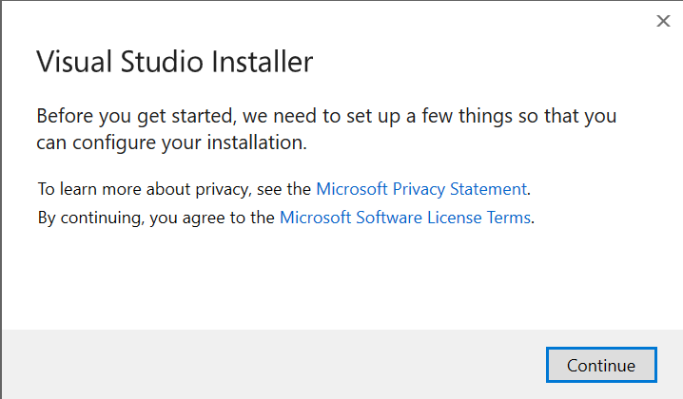
Wait for this process completion.

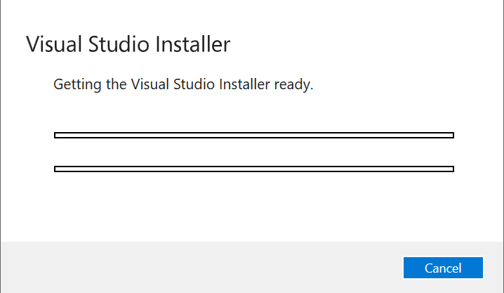
Process completed.
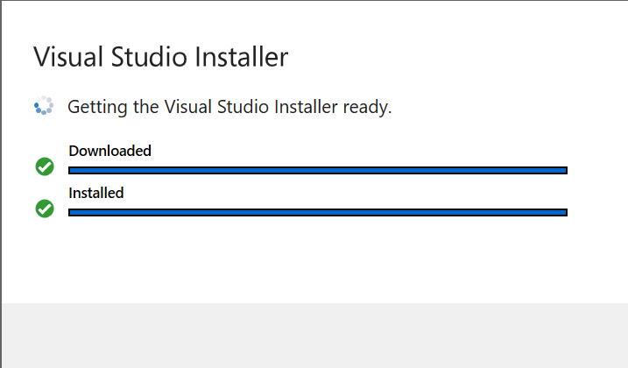
Now This workloads window will appear.

Select ASP.NET and development framework and .NET desktop Development, Check their boxes and then click on install.
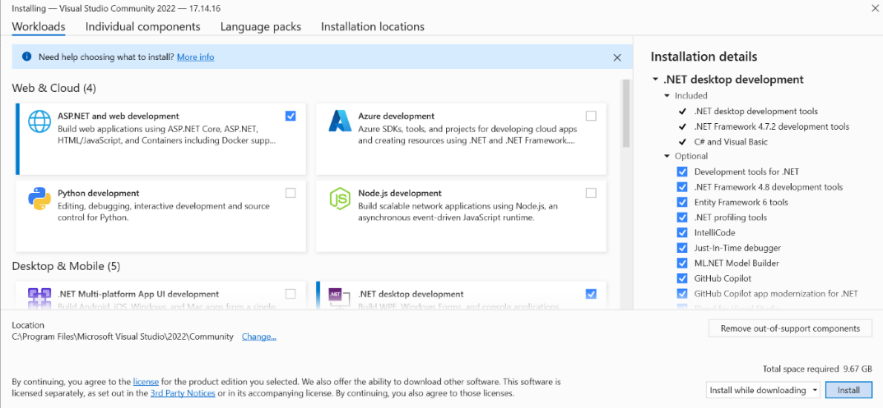

The installation process started wait for completion of this process.
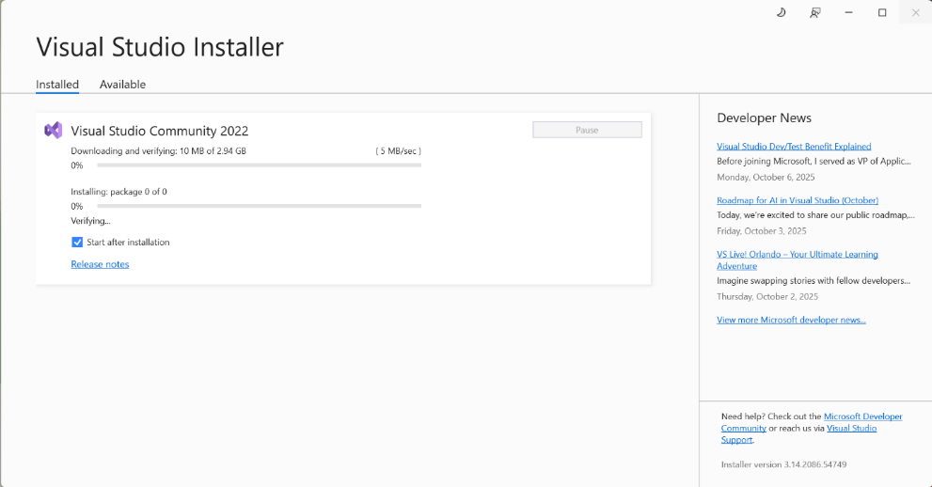

Now this window will appear this show the Visual studio installation completed successfully. Close this tab.
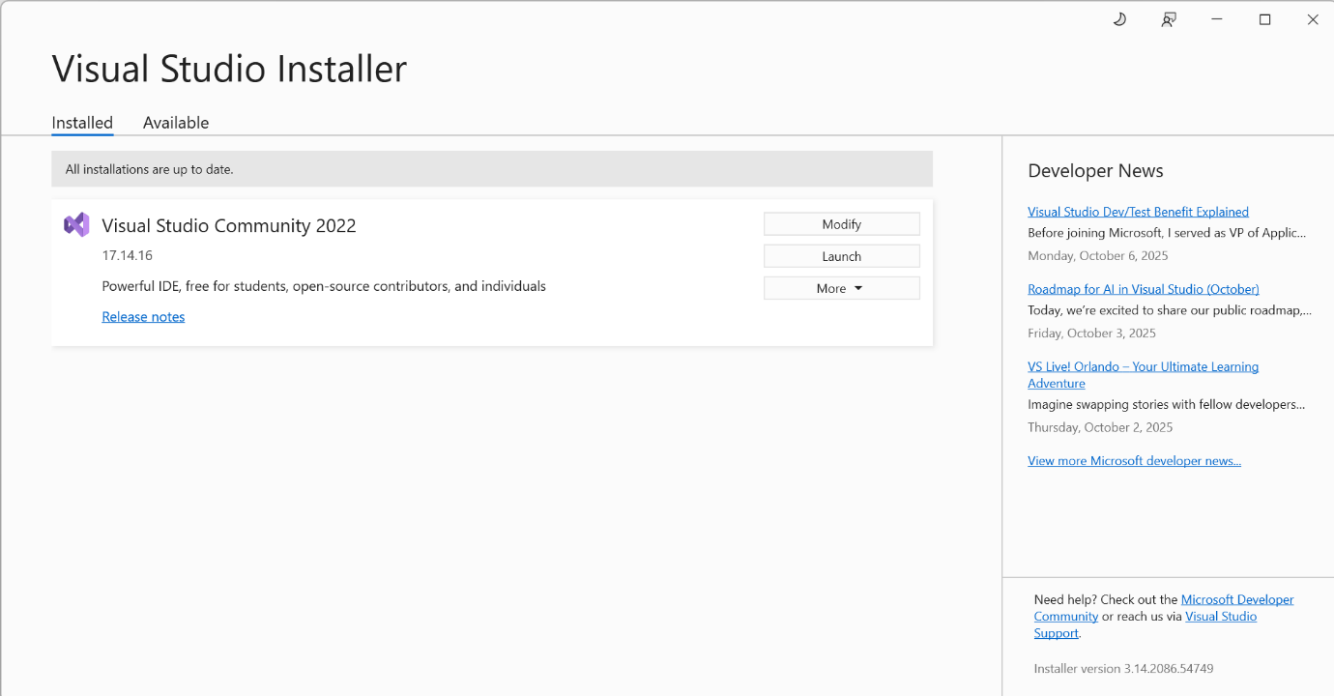
Now search visual studio in search bar and open it . After opening this window will appear click on skip and add accounts later.



This window will appear Click on Start Visual studio.

Now in this window click on Create a new project when we want to code in visual studio.

LAB#3
Programs

Task 1
Write a C# program that takes three numbers from the user and performs all arithmetic and shift operations on them.
Code:
int a, b, c, sum, sub, mul, div;
Console.WriteLine("Enter three numbers:");
a = Convert.ToInt32(Console.ReadLine());
b = Convert.ToInt32(Console.ReadLine());
c = Convert.ToInt32(Console.ReadLine());
sum = a + b + c;
sub = a - b - c;
mul = a * b * c;
div = a / b;
div = b / c;
Console.WriteLine("The Sum is:" + sum);
Console.WriteLine("The Subtract is:" + sub);
Console.WriteLine("The Multiplication is:" + mul);
Console.WriteLine("The Divison is:" + div);
int numberA;
int shiftAmountInput;
int safeShiftAmount; // Variable used to guarantee a valid shift value

Console.WriteLine("Bitwise Shift Operations ");
Console.WriteLine("Enter the starting number (A): ");
numberA = Convert.ToInt32(Console.ReadLine());

Console.WriteLine("Enter the shift amount (1-31): ");
shiftAmountInput = Convert.ToInt32(Console.ReadLine());

// Safety check: Ensures the shift amount is safe for a 32-bit integer.
// If the input is valid (1 to 31), it uses that. Otherwise, it defaults to 2.
safeShiftAmount = (shiftAmountInput > 0 && shiftAmountInput < 32) ? shiftAmountInput : 2;

Console.WriteLine("Using Shift Amount: " + safeShiftAmount);

// 2. Perform the Shift Operations (Left Shift)

// Left Shift (<<): Moves bits left.
// Result is equivalent to multiplying 'numberA' by 2 raised to the power of 'safeShiftAmount'.
int leftShift = numberA << safeShiftAmount;

// 3. Perform the Shift Operations (Right Shift)

// Right Shift (>>): Moves bits right.
// Result is equivalent to integer dividing 'numberA' by 2 raised to the power of 'safeShiftAmount'.
int rightShift = numberA >> safeShiftAmount;

// 4. Output Section
Console.WriteLine("\n Results");

Console.WriteLine("Left Shift (A << " + safeShiftAmount + "): " + leftShift);
Console.WriteLine("Right Shift (A >> " + safeShiftAmount + "): " + rightShift);
Console.ReadKey();//Control Execution
Output:

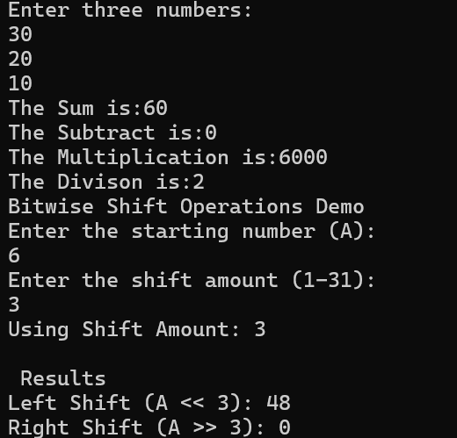
Task 2
Write a C# program to print the following pattern using loops:
****
***
**
*
Code:
int i, j;
for (i = 4; i >= 1; i--) // Outer loop: i goes from 4 down to 1
{
// Inner loop: j counts from 0 up to (i-1). This ensures 'i' stars are printed.
for (j = 0; j < i; j++)
{
Console.Write("*"); // Use Writeline() to print stars on the same line
}
// After all stars for the current row are printed, move to the next line.
Console.WriteLine();
}
Console.ReadKey();
Output:

Task 3
Take three the value of three sides of a triangle and tell if three sides are equal or not.
int sideA, sideB, sideC;
Code:
Console.WriteLine("Equilateral Triangle Checker ");

Console.Write("Enter length of Side A: ");
sideA = Convert.ToInt32(Console.ReadLine());

Console.Write("Enter length of Side B: ");
sideB = Convert.ToInt32(Console.ReadLine());

Console.Write("Enter length of Side C: ");
sideC = Convert.ToInt32(Console.ReadLine());

if (sideA == sideB && sideB == sideC)
{
// --- 4. Output Result (Equal) ---
Console.WriteLine("\nRESULT: The triangle is EQUILATERAL.");
Console.WriteLine("All three sides are equal in length.");
}
else
{
// --- 4. Output Result (Not Equal) ---
Console.WriteLine("\nRESULT: The triangle is NOT equilateral.");
Console.WriteLine("The side lengths are not all equal.");
}
Console.ReadKey();
Output:
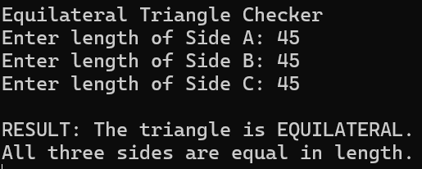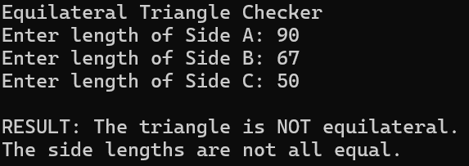
Task 4
Write a C# program that checks whether a given number is a prime number or not. The program should prompt the user to enter a number, and then it should determine if the number is prime or not. (For loop).
Code:
bool prime = true;
int n;
Console.WriteLine("Enter a number:");
n = Convert.ToInt32(Console.ReadLine());
if (n <= 1)
{
prime = false;
}
else
{
for (int i = 2; i <= n / 2; i++)
{
if (n % i == 0)
{
prime = false;
break;
}
}
}
if (prime)
Console.WriteLine(n + " Number is Prime");
else
Console.WriteLine(n + " Number is not Prime");
Console.ReadKey();
Output:
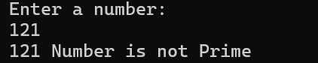
Task 5
Write a program that will take value of time in minutes and hours from user in 12-hour format. Add 5 minutes and print the time.
Code:
int inputHours, inputMinutes;

Console.WriteLine("12-Hour Time Adder ");

// Get Hours (from 1 to 12).
Console.Write("Enter hours (1 to 12): ");
inputHours = Convert.ToInt32(Console.ReadLine());

// Get Minutes (from 0 to 59)
Console.Write("Enter minutes (0 to 59): ");
inputMinutes = Convert.ToInt32(Console.ReadLine());

// --- 3. Time Calculation ---

// Convert input time to total minutes from midnight (e.g., 1:30 PM = 13 hours * 60 + 30)
int initialTotalMinutes = (inputHours * 60) + inputMinutes;

// Add the 5 minutes
int finalTotalMinutes = initialTotalMinutes + 5;

// Calculate the new minutes (0-59) using the remainder operator (%).
int finalMinutes = finalTotalMinutes % 60;

// Calculate the new 24-hour clock hours (0-23), handling day rollover with % 24.
int finalHours24 = (finalTotalMinutes / 60) % 24;

// Convert 24-hour hour (0-23) to 12-hour hour (1-12)
int finalHours12 = finalHours24 % 12;
if (finalHours12 == 0)
{
// If the remainder is 0 (00:xx or 12:xx), it should display as 12.
finalHours12 = 12;
}

// Determine AM or PM using the ternary operator (simple if/else).
string period = (finalHours24 >= 12) ? "PM" : "AM";

// Special case: 00:xx (midnight) is always AM.
if (finalHours24 == 0) period = "AM";

// --- 4. Output Section (Manual Formatting) ---

string displayMinutes;

// Custom logic to manually add a leading zero if minutes are < 10.
if (finalMinutes < 10)
{
displayMinutes = "0" + finalMinutes;
}
else
{
displayMinutes = finalMinutes.ToString();
}

Console.WriteLine("\n--- Result ---");
Console.WriteLine("Time after adding 5 minutes (12-hour format):");

// Concatenate the strings directly without String.Format.
Console.WriteLine(finalHours12 + ":" + displayMinutes + " " + period);
Console.ReadKey();
Output:

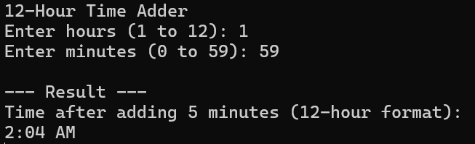
Task 6
Write the value of date from the user in day/month/year format and calculate his/her age.
Code:
Console.Write("Enter Birth Day (DD): ");
birthDay = Convert.ToInt32(Console.ReadLine());

Console.Write("Enter Birth Month (MM): ");
birthMonth = Convert.ToInt32(Console.ReadLine());

Console.Write("Enter Birth Year (YYYY): ");
birthYear = Convert.ToInt32(Console.ReadLine());

// Age Calculation

// Initial Calculation: Calculate the difference in years.
ageInYears = currentYear - birthYear;

// Check if the person's birthday has passed yet this year, based on the current date provided.

// Scenario 1: If the current month is LESS than the birth month, the birthday hasn't happened.
if (currentMonth < birthMonth)
{
// Subtract 1 year because the person hasn't had their birthday yet this year.
ageInYears = ageInYears - 1;
}
else if(currentMonth > birthMonth)
{
// If the birthday has already passed this year (currentMonth > birthMonth), the initial 'ageInYears' is correct.
}
// Scenario 2: If the current month IS the birth month, check the day.
else if (currentMonth == birthMonth)
{
// If the current day is LESS than the birth day, the birthday hasn't happened.
if (currentDay < birthDay)
{
// Subtract 1 year because the person hasn't had their birthday yet this month.
ageInYears = ageInYears - 1;
}
}
Console.WriteLine("\n Result");
Console.WriteLine("Calculating age as of " + currentDay + "/" + currentMonth + "/" + currentYear + ".");
Console.WriteLine(" calculated age is: " + ageInYears + " years.");
Console.ReadKey();
Output:
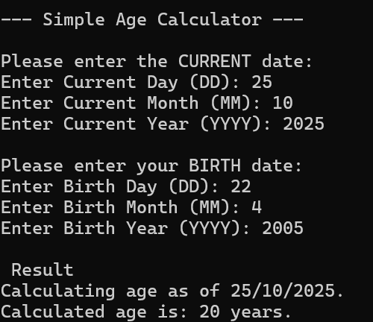
LAB#4
Array Programs
Task 1 (Single D Array)
Write a C# program uses three single-dimensional arrays, A, B, and C, each with 5 elements size. It takes input for A and B, adds their corresponding elements, stores the result in C, and displays the sum.
Code:
int[] A = new int[5];
int[] B = new int[5];
int[] C = new int[5];

// Take input for array A
Console.WriteLine("Enter 5 elements for array A:");
for (int i = 0; i < 5; i++)
{
Console.Write("A[i] = ");
A[i] = Convert.ToInt32(Console.ReadLine());
}
// Take input for array B
Console.WriteLine("Enter 5 elements for array B:");
for (int i = 0; i < 5; i++)
{
Console.Write("B[i] = ");
B[i] = Convert.ToInt32(Console.ReadLine());
}

// Add corresponding elements of A and B, store the result in C
for (int i = 0; i < 5; i++)
{
C[i] = A[i] + B[i];
}

// Display the sum of arrays
Console.WriteLine("Sum of corresponding elements of A and B:");
for (int i = 0; i < 5; i++)
{
Console.WriteLine("A[i] + B[i] = " + C[i]);
}
Console.ReadKey();
Output:

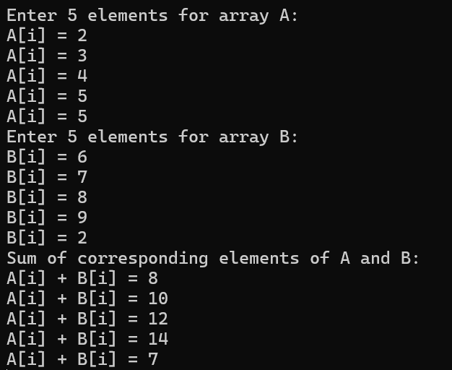

Task 2
Write a C# console application that counts how many times each element appears in an array. The program should allow the user to input the size and number of elements and then enter the array elements one by one.
Code:
// Get the size of the array from the user
Console.WriteLine("Enter the size of the array: ");
int size = Convert.ToInt32(Console.ReadLine());

// Declare an array of the specified size
int[] array = new int[size];

// Get the array elements from the user
for (int i = 0; i < size; i++)
{
Console.WriteLine("Enter element : ");
array[i] = Convert.ToInt32(Console.ReadLine());
}

// Count the occurrences of each element
for (int i = 0; i < size; i++)
{
int count = 0;
bool isVisited = false;
for (int j = 0; j < i; j++)
{
if (array[i] == array[j])
{
isVisited = true;
break;
}
}
if (!isVisited)
{
for (int j = 0; j < size; j++)
{
if (array[i] == array[j])
{
count++;
}
}
Console.WriteLine( array[i]+"appears" );
Console.WriteLine(count+ "Times");
}
}

Console.ReadKey();
Output:

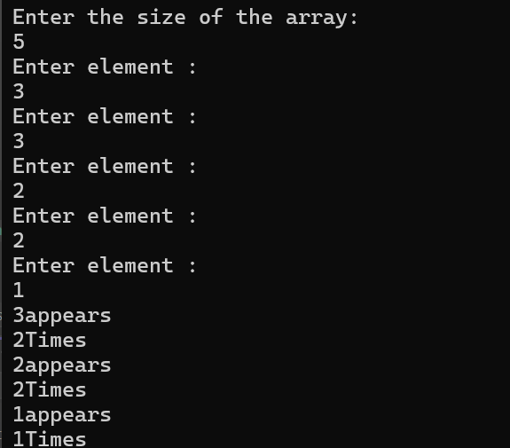
Task 3(Jagged array)

Write a C# program using a jagged array to store the marks of 5 students, where each student has a different number of subjects.
The program should allow the user to enter marks for each subject of every student and then perform the following operations for each student:
- Calculate the total marks.
- Calculate the average marks.
- Find the highest marks.
Find the lowest marks.
Finally, display the results (total, average, highest, and lowest) for all students
Code:
int[][] studentMarks = new int[5][];

for (int i = 0; i < 5; i++)
{
Console.Write("Enter number of subjects for student " + (i + 1) + ": ");
int subjects = Convert.ToInt32(Console.ReadLine());
studentMarks[i] = new int[subjects];

for (int j = 0; j < subjects; j++)
{
Console.Write("Enter marks for subject " + (j + 1) + ": ");
studentMarks[i][j] = Convert.ToInt32(Console.ReadLine());
}
}

for (int i = 0; i < 5; i++)
{
int total = 0;
int highest = studentMarks[i][0];
int lowest = studentMarks[i][0];

for (int j = 0; j < studentMarks[i].Length; j++)
{
total += studentMarks[i][j];
if (studentMarks[i][j] > highest)
{
highest = studentMarks[i][j];
}
if (studentMarks[i][j] < lowest)
{
lowest = studentMarks[i][j];
}
}

double average = (double)total / studentMarks[i].Length;

Console.WriteLine("Student " + (i + 1) + " Results:");
Console.WriteLine("Total Marks: " + total);
Console.WriteLine("Average Marks: " + average);
Console.WriteLine("Highest Marks: " + highest);
Console.WriteLine("Lowest Marks: " + lowest);
Console.WriteLine();
}

Console.ReadKey();
Output:

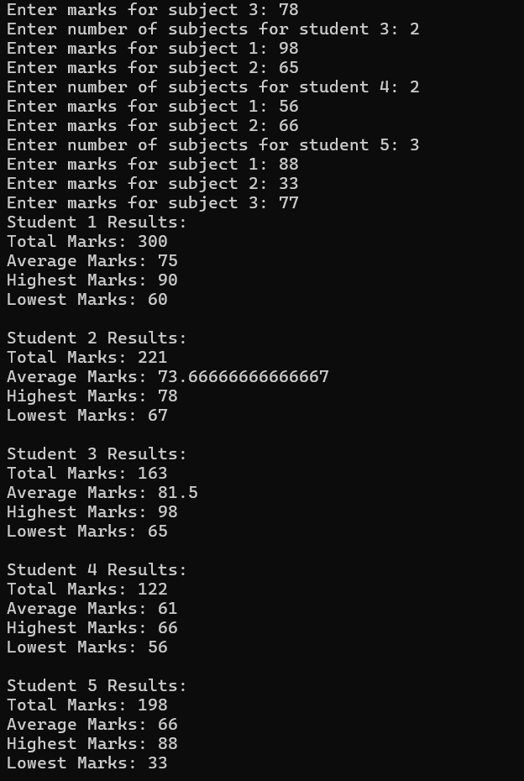

Task 4
Write a C# program to store 5 employee names in an array and display them in uppercase using a foreach loop.
Code:
// Declare an array to store employee names
string[] employeeNames = { "Nimra", "Esha", "Ayesha", "Eman", "Hira" };

// Display employee names in uppercase using foreach loop
Console.WriteLine("Employee Names in Uppercase:");
foreach (string name in employeeNames)
{
Console.WriteLine(name.ToUpper());
}

Console.ReadKey();
Output:
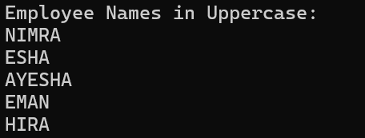
LAB#5
String builder,arraylist Programs
Task 1
Write a C# program to demonstrate various built-in methods of the StringBuilder class, including initializing, appending text, formatting text, inserting, removing, replacing, and converting the StringBuilder content into a string.
Code:
using System;
using System.Text; // Required for StringBuilder
Console.WriteLine("StringBuilder ");

// 1. Initializing a StringBuilder
StringBuilder sb = new StringBuilder("Hello");
Console.WriteLine("Initial StringBuilder content: " + sb);

// 2. Appending text
sb.Append(" World");
Console.WriteLine("After Append: " + sb);

// 3. Formatting text using AppendFormat
sb.AppendFormat(", Today is {0:dddd}", DateTime.Now);
Console.WriteLine("After AppendFormat: " + sb);

// 4. Inserting text at a specific index
sb.Insert(6, "Beautiful ");
Console.WriteLine("After Insert: " + sb);

// 5. Removing text
sb.Remove(6, 10); // Remove 10 characters starting from index 6
Console.WriteLine("After Remove: " + sb);

// 6. Replacing text
sb.Replace("World", "C#");
Console.WriteLine("After Replace: " + sb);

// 7. Converting StringBuilder to String
string result = sb.ToString();
Console.WriteLine("Converted to string: " + result);

// 8. Length and Capacity
Console.WriteLine("StringBuilder Length: " + sb.Length);
Console.WriteLine("StringBuilder Capacity: " + sb.Capacity);

// 9. Clear the content
sb.Clear();
Console.WriteLine("After Clear(): " + sb);
Output:
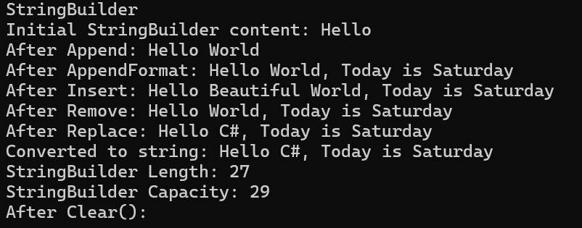
Task 2
Write a C# program to demonstrate various built-in methods of the ArrayList class, including initializing an ArrayList, adding elements, inserting at a specific index, removing elements by value and by index, replacing elements, accessing elements using an index (Get), and displaying all elements along with the total count.one.
Code:
using System;
using System.Collections; // Required for ArrayList

Console.WriteLine("ArrayList");

// 1. Initializing an ArrayList
ArrayList list = new ArrayList();
Console.WriteLine("Initialized empty ArrayList.");

// 2. Adding elements
list.Add("Apple");
list.Add("Banana");
list.Add("Cherry");
Console.WriteLine("After Adding elements:");
for (int i = 0; i < list.Count; i++)
{
Console.WriteLine(list[i]);
}

// 3. Inserting at a specific index
list.Insert(1, "Orange"); // Insert "Orange" at index 1
Console.WriteLine("After Inserting 'Orange' at index 1:");
for (int i = 0; i < list.Count; i++)
{
Console.WriteLine(list[i]);
}

// 4. Removing elements by value
list.Remove("Banana");
Console.WriteLine("After Removing 'Banana' by value:");
for (int i = 0; i < list.Count; i++)
{
Console.WriteLine(list[i]);
}

// 5. Removing element by index
list.RemoveAt(2); // Remove element at index 2
Console.WriteLine("After Removing element at index 2:");
for (int i = 0; i < list.Count; i++)
{
Console.WriteLine(list[i]);
}

// 6. Replacing elements (using index)
list[1] = "Grapes"; // Replace element at index 1
Console.WriteLine("After Replacing element at index 1 with 'Grapes':");
for (int i = 0; i < list.Count; i++)
{
Console.WriteLine(list[i]);
}

// 7. Accessing elements using index (Get)
Console.WriteLine("Accessing element at index 0: " + list[0]);

// 8. Display total count
Console.WriteLine("Total number of elements: " + list.Count);
Output:
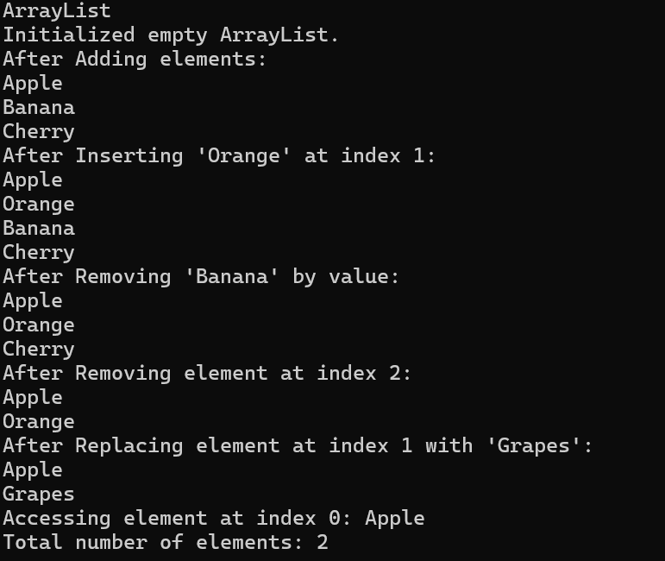
Task 3
Write a C# program that uses the StringBuilder class to create a short story. The program should take four inputs from the user as per wish. Then it should build a story using those inputs and display it on the console.
Code:
using System;
using System.Text;
StringBuilder story = new StringBuilder();
string name, place, objectName;

Console.WriteLine(" Story Builder using StringBuilder");

Console.Write("Enter a name: ");
name = Console.ReadLine();

Console.Write("Enter a place: ");
place = Console.ReadLine();

Console.Write("Enter an object: ");
objectName = Console.ReadLine();

story.AppendLine("Once upon a time, there was a person named "+name);
story.AppendLine($"{name} lived in a beautiful city called {place}.");
story.AppendLine($"One day, {name} found a magical {objectName} that granted wishes.");
story.AppendLine($"From that day on, {name} became the happiest person in {place}.");
story.AppendLine("The End ");
Console.WriteLine("Here is story:");
Console.WriteLine(story.ToString());

Output:
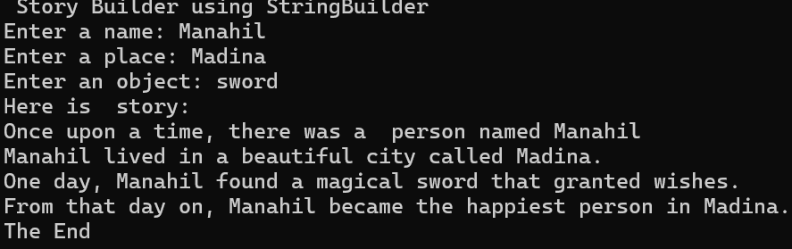
LAB#6
Class ,Methods Programs
Task 1
Write a program in C# Sharp to create a function to input a string and count the number of spaces within the string.
Code:
class program
{
static int count_space(string str)
{

int countspace = 0;
for (int i = 0; i < str.Length; i++)
{
if (str[i] == ' ')
{
countspace++;
}
}
return countspace;
}
static void Main()
{
Console.WriteLine("Enter a string");
string str = Console.ReadLine();
int spaces = count_space(str);// function call
Console.WriteLine("Number of spaces:" + spaces);
}
}
Output:
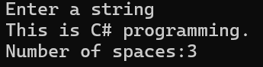
Task 2
Write a C# program using Function Overloading to calculate the Perimeter of different shapes: Square, Rectangle, Cuboid. Use the same method name Perimeter() but with different parameter lists to perform each calculation.
Code:
using System;

class overloading
{
// Perimeter of a Square (4 sides)
static double Perimeter(double side)
{
return 4 * side;
}

// Perimeter of a Rectangle (2*(length + width))
static double Perimeter(double length, double width)
{
return 2 * (length + width);
}

// Perimeter of a Cuboid (Sum of edges: 4*(length + width + height))
static double Perimeter(double length, double width, double height)
{
return 4 * (length + width + height);
}

static void Main()
{
Console.WriteLine("Perimeter Calculator using Function Overloading\n");

// Square
Console.Write("Enter the side of the square: ");
double side = Convert.ToDouble(Console.ReadLine());
Console.WriteLine("Perimeter of Square: " + Perimeter(side));

// Rectangle
Console.Write("Enter the length of the rectangle: ");
double length = Convert.ToDouble(Console.ReadLine());
Console.Write("Enter the width of the rectangle: ");
double width = Convert.ToDouble(Console.ReadLine());
Console.WriteLine("Perimeter of Rectangle: " + Perimeter(length, width));

// Cuboid
Console.Write("Enter the length of the cuboid: ");
double cuboidLength = Convert.ToDouble(Console.ReadLine());
Console.Write("Enter the width of the cuboid: ");
double cuboidWidth = Convert.ToDouble(Console.ReadLine());
Console.Write("Enter the height of the cuboid: ");
double cuboidHeight = Convert.ToDouble(Console.ReadLine());
Console.WriteLine("Perimeter of Cuboid (sum of edges): " + Perimeter(cuboidLength, cuboidWidth, cuboidHeight));
}
}
Output:
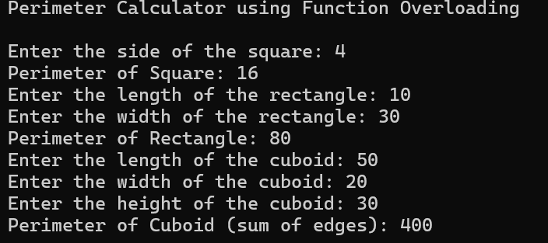
Task 3
Write a C# program that takes the names and marks of 10 students, stores them, and then sorts the list in two different ways:
- By Name (alphabetically)
- By Marks (in ascending order)
Use two separate functions for each type of sorting and display the sorted lists.
Code:
using System;

class sorting
{
// Function to sort by name
static void SortByName(string[] names, int[] marks)
{
for (int i = 0; i < names.Length - 1; i++)
{
for (int j = i + 1; j < names.Length; j++)
{
if (names[i].CompareTo(names[j]) > 0)
{
// swap names
string tempName = names[i];
names[i] = names[j];
names[j] = tempName;

// swap marks
int tempMark = marks[i];
marks[i] = marks[j];
marks[j] = tempMark;
}
}
}

Console.WriteLine("\nStudents Sorted by Name:");
for (int i = 0; i < names.Length; i++)
{
Console.WriteLine(names[i] + " - " + marks[i]);
}
}

// Function to sort by marks
static void SortByMarks(string[] names, int[] marks)
{
for (int i = 0; i < marks.Length - 1; i++)
{
for (int j = i + 1; j < marks.Length; j++)
{
if (marks[i] > marks[j])
{
// swap marks
int tempMark = marks[i];
marks[i] = marks[j];
marks[j] = tempMark;

// swap names
string tempName = names[i];
names[i] = names[j];
names[j] = tempName;
}
}
}

Console.WriteLine("Students Sorted by Marks:");
for (int i = 0; i < names.Length; i++)
{
Console.WriteLine(names[i] + " - " + marks[i]);
}
}

static void Main()
{
string[] names = new string[10];
int[] marks = new int[10];

Console.WriteLine("Enter names and marks of 10 students:");

for (int i = 0; i < 10; i++)
{
Console.Write("Enter name of student " + (i + 1) + ": ");
names[i] = Console.ReadLine();

Console.Write("Enter marks of " + names[i] + ": ");
marks[i] = Convert.ToInt32(Console.ReadLine());
}

SortByName(names, marks); // Sort alphabetically
SortByMarks(names, marks); // Sort by marks
}
}
Output:
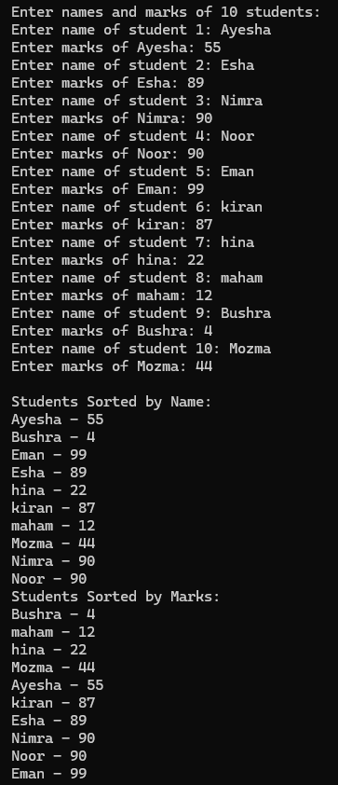

Task 4
Write a C# program to demonstrate the Copy Constructor concept using a class Book.
Each book has a title, author, price, and a Publisher (as another class). The copy constructor should create a deep copy of the book, meaning that if we change the publisher in the copied object, the original one remains unchanged.
Code:
using System;
using System.Diagnostics;
class Publisher
{
public string Name;
public string City;
public Publisher(string name, string city)
{
Name = name;
City = city;
}
public void Display()
{
Console.WriteLine("Publisher:" + Name );
Console.WriteLine("Publisher:" + City);
}
};
class Book
{
public string Title;
public string Author;
public int Price;
public Publisher Pub;
Book(string title, string author, int price, Publisher pub)
{
Title = title;
Author = author;
Price = price;
Pub = new Publisher(pub.Name, pub.City);

}
public void Display()
{
Console.WriteLine("Book Details");
Console.WriteLine("Book Title"+Title);
Console.WriteLine("Book Author"+Author);
Console.WriteLine("Book price"+Price);
Console.WriteLine("Publisher:"+Pub.Name );
Console.WriteLine("Publisher:" + Pub.City);
}
static void Main()
{
Publisher pub = new Publisher("oxford", "Lahore");
Book book = new Book("C# Basic", "XYZ", 1200, pub);
pub.Display();
book.Display();
}
}
Output:
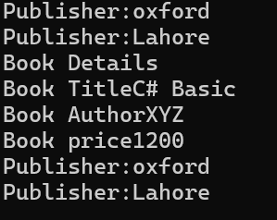
Task 5
Write a C# program & Create a class BankAccount that hides account balance and allows deposit and withdrawal through properties. Prevent negative balance using encapsulation.
Code:
using System;

class BankAccount
{
// Private field - hidden from outside
private double balance;

// Constructor to initialize balance
public BankAccount(double initialBalance)
{
if (initialBalance >= 0)
balance = initialBalance;
else
balance = 0;
}

// Property to deposit money
public double Deposit
{
set
{
if (value > 0)
balance += value;
else
Console.WriteLine("Deposit amount must be positive!");
}
}

// Property to withdraw money
public double Withdraw
{
set
{
if (value > 0)
{
if (value <= balance)
balance -= value;
else
Console.WriteLine("Insufficient balance! Cannot withdraw more than current balance.");
}
else
Console.WriteLine("Withdrawal amount must be positive!");
}
}

// Property to get current balance
public double Balance
{
get { return balance; }
}
}

class Program
{
static void Main()
{
Console.Write("Enter initial balance: ");
double initial = Convert.ToDouble(Console.ReadLine());

BankAccount account = new BankAccount(initial);//object

Console.WriteLine("Current Balance: " + account.Balance);

// Deposit
Console.Write("Enter amount to deposit: ");
double depositAmount = Convert.ToDouble(Console.ReadLine());
account.Deposit = depositAmount;
Console.WriteLine("Balance after deposit: " + account.Balance);

// Withdraw
Console.Write("Enter amount to withdraw: ");
double withdrawAmount = Convert.ToDouble(Console.ReadLine());
account.Withdraw = withdrawAmount;
Console.WriteLine("Balance after withdrawal: " + account.Balance);
}
}
Output:
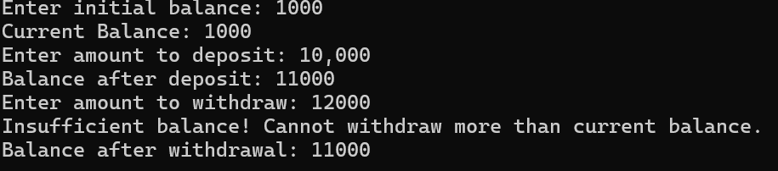

LAB#7
Task 1
Write a class NatPhone that inherits from the LocalPhone class to represent national phone numbers. It includes an additional attribute to store the city code and an array of two LocalPhone objects to manage multiple local numbers. Member functions are provided to input and display both the city code and the details of the local phones.
Code:
using System.Transactions;

class Local_phone
{
public long number;
public void input()
{
Console.WriteLine("Enter the number");
number = Convert.ToInt64(Console.ReadLine());
}
public void display()
{
Console.WriteLine("number is:" + number);
}
}
class Nat_phone : Local_phone
{
public int city_code;
public Local_phone[] lp = new Local_phone[2];
public void input()
{
base.input();
Console.WriteLine("Enter city_code");
city_code = Convert.ToInt32(Console.ReadLine());
for (int i = 0; i < lp.Length; i++)
{
lp[i] = new Local_phone();
Console.WriteLine($"Enter details for Local_phone:lp{i + 1}");
lp[i].input();
}
}
public void display()
{
base.display();
Console.WriteLine("city_code is:" + city_code);
for (int i = 0; i < lp.Length; i++)
{
Console.WriteLine($"Local Pone details are:lp {i + 1}");
lp[i].display();
}
}
static void Main()
{
Nat_phone np = new Nat_phone();
np.input();
np.display();
}
}
Output:
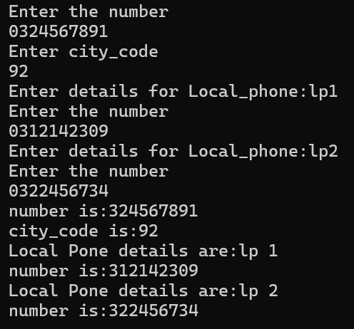
Task 2
Create a class BankAccount with data members account no, account title, and balance, and methods deposit, withdraw, and getaccountdetails. Perform the following tasks:
- Remember no one should be able to access/modify balance directly.
- Inherit class savingaccount from bankaccount with additional fields of account type. Override method getaccountdetails.
- Create objects for bankaccount and savingaccount and print account details for both.
Code:
using System.ComponentModel.Design;
using System.Security.AccessControl;

class Bank_Account
{

private int account_no;
private string account_title;
private double balance;
public void setdetails(int a, string t, double b)
{
account_no = a;
account_title = t;
balance = b;
}
public void deposit(double value)
{
if (value > 0)
{
balance += value;
}
else
Console.WriteLine("deposit amount must be positive");
}
public void Withdraw(double value)
{
if (value > 0)
{
if (value <= balance)
{
balance -= value;
}
else
{
Console.WriteLine("Insufficient balance! Cannot withdraw more then current balance");
}
}
else
{
Console.WriteLine("Balance must be positive");
}
}
virtual public void getaccountdetails()
{
Console.WriteLine("Bank_Account details are:");
Console.WriteLine("Bank account number is:");
Console.WriteLine(account_no);
Console.WriteLine("Bank account title is:");
Console.WriteLine(account_title);
Console.WriteLine("Remaining balance is:");
Console.WriteLine(balance);
}
class saving_acc : Bank_Account
{
private string acc_type;
public void setsavingdetail(int a, string t, double b, string type)
{
setdetails(a, t, b);
acc_type = type;
}
public override void getaccountdetails()
{
base.getaccountdetails();
Console.WriteLine("Account type is:");
Console.WriteLine(acc_type);
}
}
static void Main()
{
Bank_Account account = new Bank_Account();
Console.WriteLine("Enter account number:");
account.account_no = Convert.ToInt32(Console.ReadLine());
Console.WriteLine("Enter account Title:");
account.account_title = (Console.ReadLine());
Console.WriteLine("Enter account balance:");
account.balance = Convert.ToDouble(Console.ReadLine());
Console.WriteLine("Balance before deposit: " + account.balance);
account.deposit(550.12);
Console.WriteLine("Balance after deposit: " + account.balance);
account.Withdraw(1000.0);
Console.WriteLine("Balance after withdraw: " + account.balance);
account.setdetails(account.account_no, account.account_title, account.balance);
saving_acc saving = new saving_acc();
Console.WriteLine("Enter account type for saving account:");
string type = Console.ReadLine();
saving.setsavingdetail(account.account_no, account.account_title, account.balance, type);
Console.WriteLine("parent saving details:");
account.getaccountdetails();
Console.WriteLine("Child saving details:");
saving.getaccountdetails();

}
}
Output:
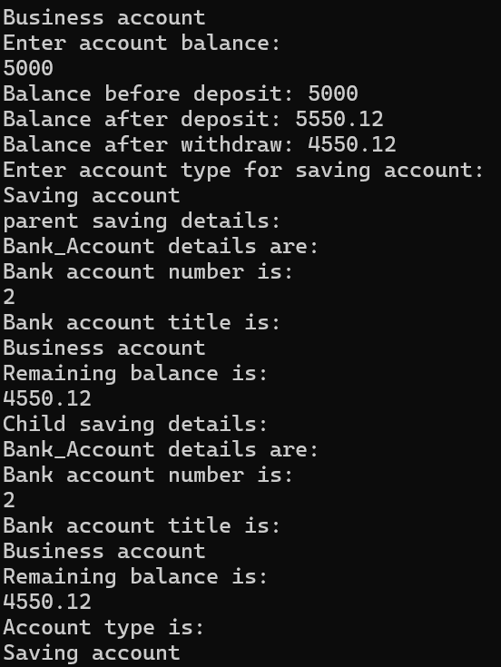
Task 3
Write a C# Program to rotate an Arraylist of size 10 in left and right Direction three times. Create a Class of ArrayRotate with data member of integer type arraylist of size 10, property of that member, user define displayArray() Method, RotateLeft(ArrayList arl) Method, RotateRight(ArrayList arl) Method.
1 | 2 | 3 | 4 | 5 | 6 | 7 | 8 | 9 | 10
e.g if the Given ArrayList is:
The after calling RotateLeft(int[] arr) Method the arraylist would be
4 | 5 | 6 | 7 | 8 | 9 | 10 | 1 | 2 | 3

Then after calling RotateRight(int[] arr) Method the arraylist would be
8 | 9 | 10 | 1 | 2 | 3 | 4 | 5 | 6 | 7

Code:
using System.Collections;

class ArrayRotate
{
private ArrayList numbers;
public ArrayList Numbers
{
get { return numbers; }
set {numbers = value; }
}
public ArrayRotate(ArrayList list)//constructor
{
numbers=list;
}
public void Display()
{
for(int i = 0; i < numbers.Count; i++)
{
Console.WriteLine( numbers[i] + "");
}
}
public void Rotate_left()
{
for(int r=0;r<3;r++)
{
int first =(int) numbers[0];//type casting use or use object
numbers.RemoveAt(0);
numbers.Add(first);//add at end
}
}
public void Rotate_Right()
{
for (int r = 0; r < 3; r++)
{
int last = (int)numbers[numbers.Count - 1];
numbers.RemoveAt(numbers.Count - 1);
numbers.Insert(0,last);
}
}
static void Main()
{
ArrayList arr = new ArrayList();
Console.WriteLine("Enter 10 numbers in ArrayList");

// Input
for (int i = 0; i < 10; i++)
{
arr.Add(Convert.ToInt32(Console.ReadLine()));
}
//copy of original array
ArrayList originalBackup = new ArrayList();
foreach (var item in arr)
{
originalBackup.Add(item);
}

//LEFT ROTATION

ArrayRotate leftobj = new ArrayRotate(arr);

Console.WriteLine("Original ArrayList:");
leftobj.Display();

leftobj.Rotate_left();

Console.WriteLine("After RotateLeft ArrayList (3 times):");
leftobj.Display();

// RIGHT ROTATION

// Initialize the second object using the copy list
ArrayRotate rightobj = new ArrayRotate(originalBackup);

rightobj.Rotate_Right();

Console.WriteLine("After RotateRight ArrayList (3 times):");
rightobj.Display();
}
}
Output:
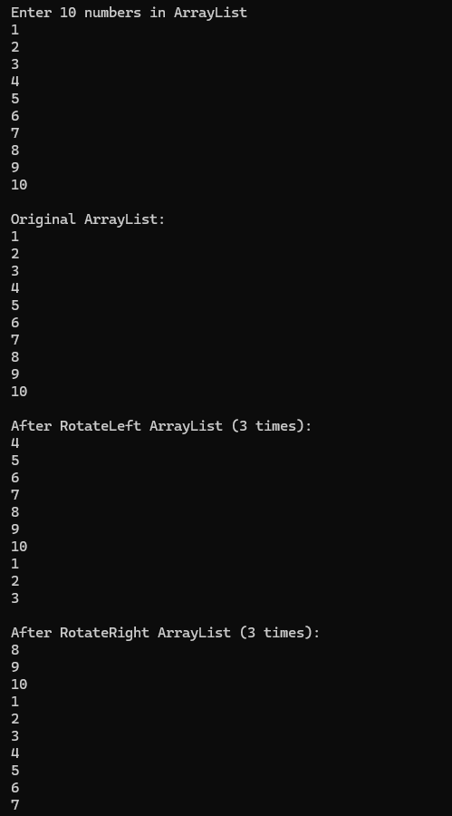
Task 4
Write a class Teacher that contains the attributes teacher name, age, and address. It also contains member functions to input and display its attributes. Write a child class Author that inherits from the Teacher class. The Author class contains attributes writer name and number of books written. It also contains member functions to input and display its attributes.
Write another child class Scholar that also inherits from the Teacher class. The Scholar class contains attributes research topic and year of research. It also contains member functions to input and display its attributes.
Code:
class Teacher
{
public string teacher_name;
public int age;
public int address;
public void Teacher_input()
{
Console.WriteLine("Enter teacher name:");
string teacher_name = Console.ReadLine();
Console.WriteLine("Enter age:");
age = Convert.ToInt32(Console.ReadLine());
Console.WriteLine("Enter address:");
address = Convert.ToInt32(Console.ReadLine());
}
public void Teacher_display()
{
Console.WriteLine("Teacher name is:" + teacher_name);
Console.WriteLine(" age is:" + age);
Console.WriteLine("Address is:" + address);
}
}
class Author : Teacher
{
public string writer_name;
public int book_written;
public void Author_input()
{
Teacher_input();
Console.WriteLine("Enter writer name:");
string writer_name = Console.ReadLine();
Console.WriteLine("Enter number if books written:");
book_written = Convert.ToInt32(Console.ReadLine());
}
public void Author_display()
{
Teacher_display();
Console.WriteLine("writer name name is:" + writer_name);
Console.WriteLine(" Books written by author is:" + book_written);
}
}
class Scholar : Teacher
{

public string research_topic;
public int year;
public void Scholar_input()
{
Teacher_input();
Console.WriteLine("Enter Research topic:");
string research_topic = Console.ReadLine();
Console.WriteLine("Enter Year of Research:");
year = Convert.ToInt32(Console.ReadLine());
}
public void Scholar_display()
{
Teacher_display();
Console.WriteLine("Research Topic is:" + research_topic);
Console.WriteLine(" Year of Research is:" + year);
}
static void Main()
{
Author a = new Author();
a.Author_input();
a.Author_display();
Scholar s = new Scholar();
s.Scholar_input();
s.Scholar_display();
}

}
Output:

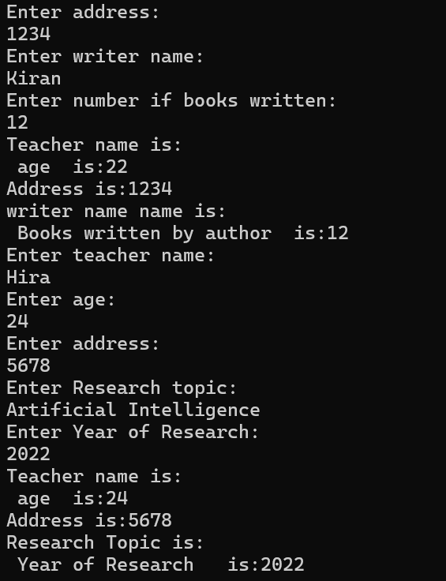
Lab#8
Calculator
Form:
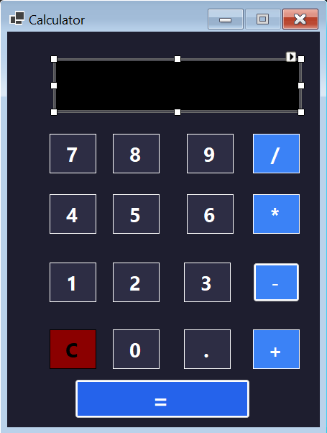
Code:
using System;
using System.Windows.Forms;

namespace Calculator
{
public partial class Form1 : Form
{
double num1 = 0, num2 = 0;
string op = "";

public Form1()
{
InitializeComponent();
txtDisplay.Text = "0";
}
private void button1_Click(object sender, EventArgs e) // 0
{
if (txtDisplay.Text == "0" || txtDisplay.Text == "")
txtDisplay.Text = "0";
else
txtDisplay.Text += "0";
}
private void button2_Click(object sender, EventArgs e) // 1
{
if (txtDisplay.Text == "0" || txtDisplay.Text == "")
txtDisplay.Text = "1";
else
txtDisplay.Text += "1";
}
private void button3_Click(object sender, EventArgs e) // 2
{
if (txtDisplay.Text == "0" || txtDisplay.Text == "")
txtDisplay.Text = "2";
else
txtDisplay.Text += "2";
}

private void button4_Click(object sender, EventArgs e) // 3
{
if (txtDisplay.Text == "0" || txtDisplay.Text == "")
txtDisplay.Text = "3";
else
txtDisplay.Text += "3";
}
private void button5_Click(object sender, EventArgs e) // 4
{
if (txtDisplay.Text == "0" || txtDisplay.Text == "")
txtDisplay.Text = "4";
else
txtDisplay.Text += "4";
}
private void button6_Click(object sender, EventArgs e) // 5
{
if (txtDisplay.Text == "0" || txtDisplay.Text == "")
txtDisplay.Text = "5";
else
txtDisplay.Text += "5";
}
private void button7_Click(object sender, EventArgs e) // 6
{
if (txtDisplay.Text == "0" || txtDisplay.Text == "")
txtDisplay.Text = "6";
else
txtDisplay.Text += "6";
}
private void button8_Click(object sender, EventArgs e) // 7
{
if (txtDisplay.Text == "0" || txtDisplay.Text == "")
txtDisplay.Text = "7";
else
txtDisplay.Text += "7";
}
private void button9_Click(object sender, EventArgs e) // 8
{
if (txtDisplay.Text == "0" || txtDisplay.Text == "")
txtDisplay.Text = "8";
else
txtDisplay.Text += "8";
}
private void button10_Click(object sender, EventArgs e) // 9
{
if (txtDisplay.Text == "0" || txtDisplay.Text == "")
txtDisplay.Text = "9";
else
txtDisplay.Text += "9";
}
private void ApplyPreviousOperation()
{
if (op == "" && txtDisplay.Text != "")
{
num1 = Convert.ToDouble(txtDisplay.Text);
return;
}
if (op != "" && txtDisplay.Text != "")
{
num2 = Convert.ToDouble(txtDisplay.Text);

if (op == "+") num1 += num2;
else if (op == "-") num1 -= num2;
else if (op == "*") num1 *= num2;
else if (op == "/")
{
if (num2 == 0)
{
MessageBox.Show("Cannot divide by zero");
return;
}
num1 /= num2;
}
}
}
private void button11_Click(object sender, EventArgs e) // +
{
ApplyPreviousOperation();
op = "+";
txtDisplay.Text = "";
}

private void button12_Click(object sender, EventArgs e) // -
{
ApplyPreviousOperation();
op = "-";
txtDisplay.Text = "";
}
private void button13_Click(object sender, EventArgs e) // *
{
ApplyPreviousOperation();
op = "*";
txtDisplay.Text = "";
}

private void button14_Click(object sender, EventArgs e) // /
{
ApplyPreviousOperation();
op = "/";
txtDisplay.Text = "";
}
private void button16_Click(object sender, EventArgs e) // =
{
ApplyPreviousOperation();
txtDisplay.Text = num1.ToString();
op = "";
}
private void button15_Click(object sender, EventArgs e) // C
{
txtDisplay.Text = "0";
num1 = 0;
num2 = 0;
op = "";
}
private void button17_Click(object sender, EventArgs e) // .
{
if (txtDisplay.Text == "")
txtDisplay.Text = "0.";
else if (!txtDisplay.Text.Contains("."))
txtDisplay.Text += ".";
}
private void txtDisplay_TextChanged(object sender, EventArgs e)
{
}
}
}

Output:
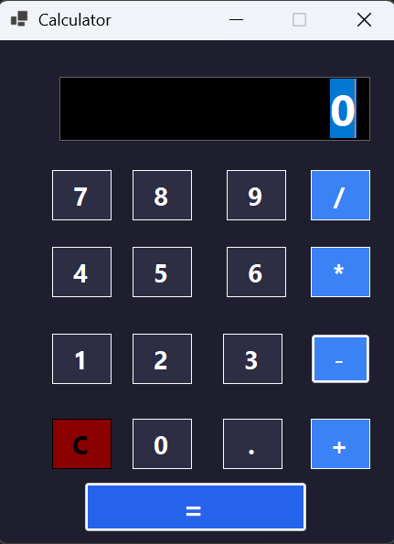
Addition:
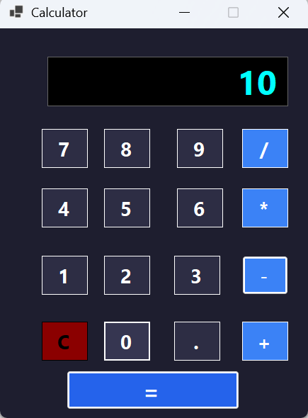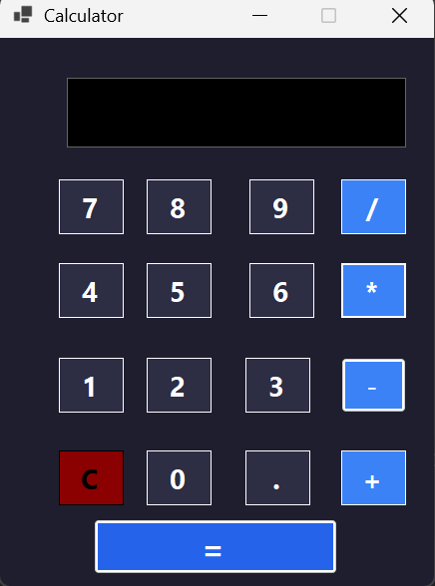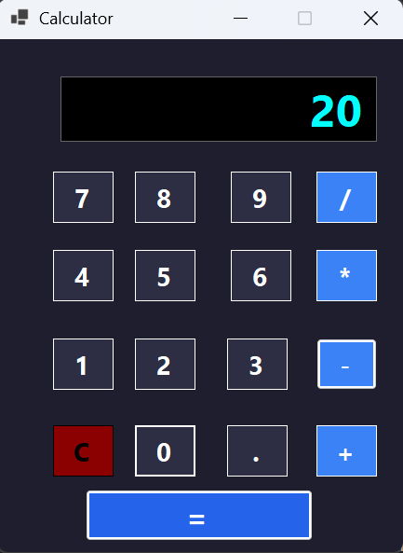
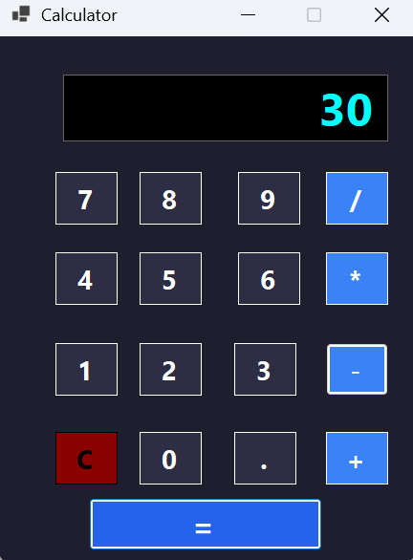
Multiple operators (6+7+6):
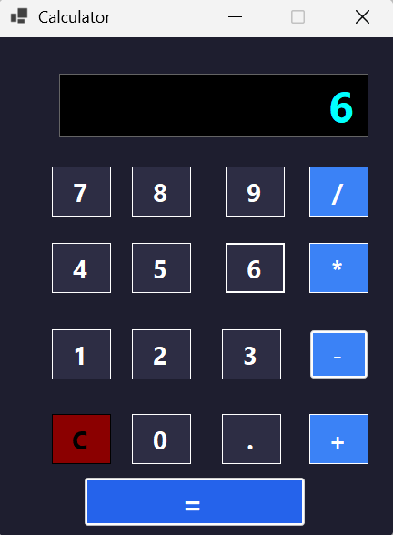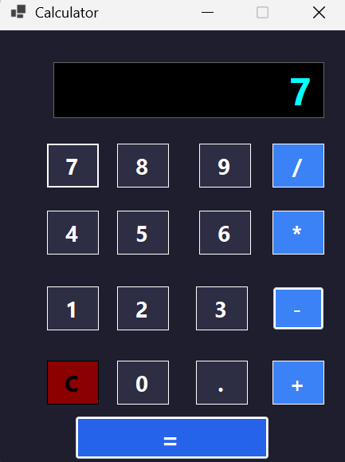
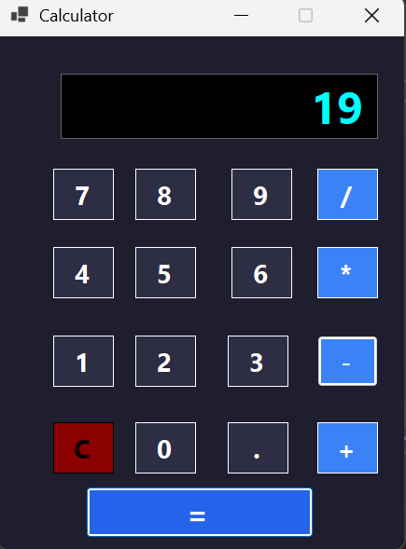
Using Clear C:
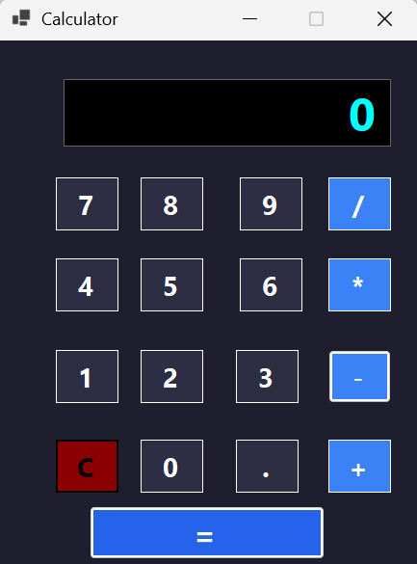
Subtraction:
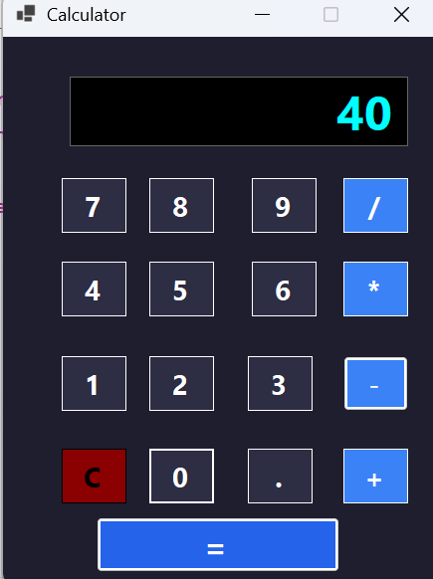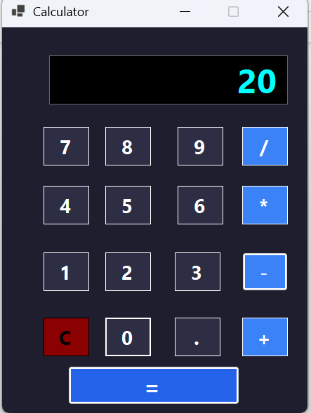

Multiplication:
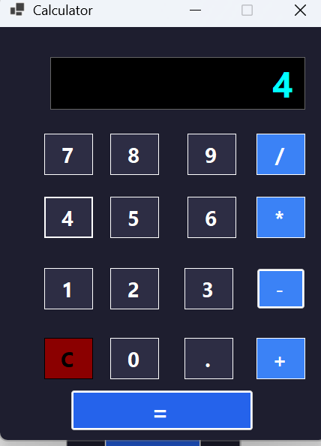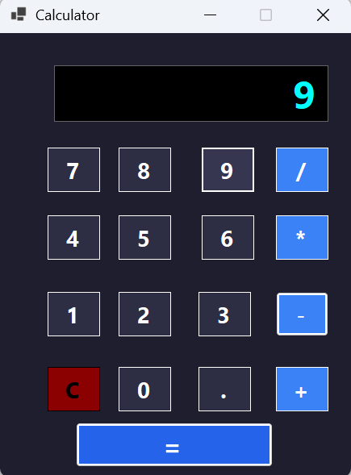
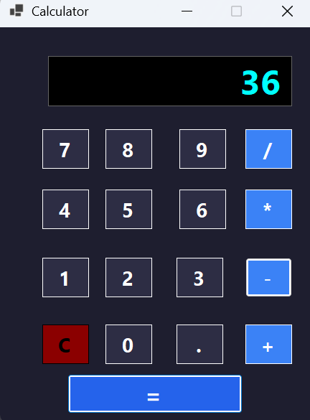
Division:
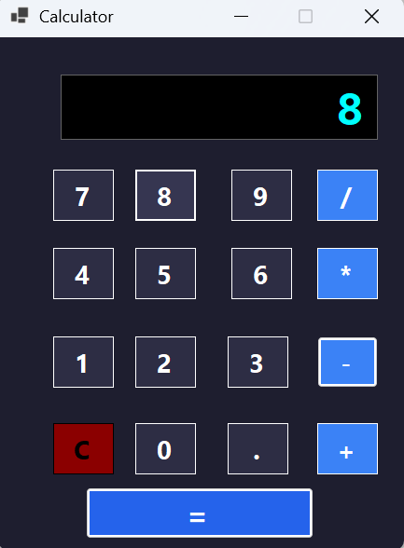
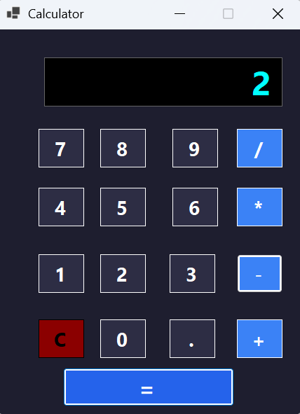
Lab#09

